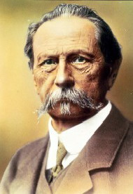
Mercedes-Benz traces its origins to Karl Benz's creation of the first petrol-powered car, the Benz Patent Motorwagen, patented in January 1886 and Gottlieb Daimler and engineer Wilhelm Maybach's conversion of a stagecoach by the addition of a petrol engine later that year. The Mercedes automobile was first marketed in 1901 by Daimler Motoren Gesellschaft. The first Mercedes-Benz brand name vehicles were produced in 1926, following the merger of Karl Benz's and Gottlieb Daimler's com panies into the Daimler-Benz company. Throughout the 1930s, Mercedes-Benz produced the 770 model, a car that was popular during Germany's Nazi period. Adolf Hitler was known to have driven multiple of these cars during his time in power, with bulletproof windshields. Most of the surviving models have been sold at auctions to private buyers. One of them is currently on display at the War Museum in Ottawa, Ontario. Mercedes-Benz has introduced many technological and safety innovations that later became common in other vehicles. Mercedes-Benz is one of the best known and established automotive brands in the world, and is also the world's oldest automotive brand still in existence today. For information relating to the famous three-pointed star, see under the title Daimler Motoren Gesellschaft including the merger into Daimler-Benz.
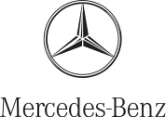
Since its inception, Mercedes-Benz had maintained a reputation for its quality and durability. Objective measures looking at passenger vehicles, such as J. D. Power surveys, demonstrated a downturn in reputation in these criteria in the late 1990s and early 2000s. By mid-2005, Mercedes temporarily returned to the industry average for initial quality, a measure of problems after the first 90 days of ownership, according to J.D. Power. In J.D. Power's Initial Quality Study for the first quarter of 2007, Mercedes showed dramatic improvement by climbing from 25th to 5th place and earning several awards for its models. For 2008, Mercedes-Benz's initial quality rating improved by yet another mark, to fourth place. On top of this accolade, it also received the Platinum Plant Quality Award for its Mercedes’ Sindelfingen, Germany assembly plant. J.D. Power's 2011 US Initial Quality and Vehicle Dependability Studies both ranked Mercedes-Benz vehicles above average in build quality and reliability. In the 2011 UK JD Power Survey, Mercedes cars rated above average.

Environmental record
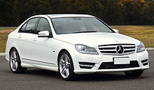
Mercedes-Benz has developed multi concept cars with alternative propulsion, such as hybrid-electric, fully electric, and fuel-cell powertrains. At the 2007 Frankfurt motor show, Mercedes-Benz showed seven hybrid models, including the F700 concept car, powered by a hybrid-electric drivetrain featuring the DiesOtto engine. In 2009, Mercedes-Benz displayed three BlueZERO concepts at the North American International Auto Show. Each car features a different powertrain - battery-electric, fuel-cell electric, and gasoline-electric hybrid. In the same year, Mercedes also showed the Vision S500 PHEV concept with a 19 miles (31 km) all-electric range and CO₂ emissions of 74 grams/km in the New European Driving Cycle. Since 2002, Mercedes-Benz has developed the F-Cell fuel cell vehicle. The current version, based on the B-Class, has a 250 mile range and is available for lease, with volume production scheduled to begin in 2014. Mercedes has also announced the SLS AMG E-Cell, a fully electric version of the SLS sports car, with deliveries expected in 2013. The Mercedes-Benz S400 BlueHYBRID was launched in 2009, and is the first production automotive hybrid in the world to use a lithium-ion battery. In mid-2010, production commenced on the Vito E-Cell all-electric van. Mercedes expects 100 vehicles to be produced by the end of 2010 and a further 2000 by the end of 2011. In 2008, Mercedes-Benz announced that it would have a demonstration fleet of small electric cars in two to three years. Mercedes-Benz and Smart are preparing for the widespread uptake of electric vehicles (EVs) in the UK by beginning the installation of recharging points across their dealer networks. So far 20 Elektrobay recharging units, produced in the UK by Brighton-based Elektromotive, have been installed at seven locations as part of a pilot project, and further expansion of the initiative is planned later in 2010.
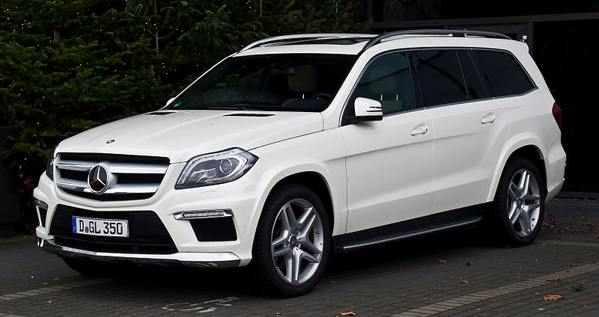
In the United States, Mercedes-Benz was assessed a record US$30.66 million for their decision to not meet the federal corporate average fuel economy standard in 2009. Certain Mercedes-Benz cars, including the S550 and all AMG models sold in the United States, also face an additional gas guzzler tax. However, newer AMG models fitted with the M157 engine will not be subject to the gas-guzzler tax, due to improved fuel economy, and newer models powered by the M276 and M278 engines will have better fuel economy. In 2008, Mercedes also had the worst CO₂ average of all major European manufacturers, ranking 14th out of 14 manufacturers. Mercedes was also the worst manufacturer in 2007 and 2006 in terms of average CO₂ levels, with 181 g and 188 g of CO₂ emitted per km, respectively.

Robot cars
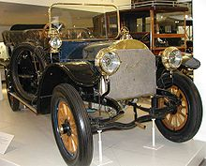
In the 1980s, Mercedes built the world's first robot car, together with the team of Professor Ernst Dickmanns at Bundeswehr University Munich. Partially encouraged by Dickmanns' success, in 1987 the European Union's EUREKA programme initiated the Prometheus Project on autonomous vehicles, funded to the tune of nearly €800 million. A culmination point was ach eved in 1995, when Dickmanns' re-engineered autonomous S-Class Mercedes took a long trip from Munich in Bavaria to Copenhagen in Denmark, and back. On highways, the robot achieved speeds exceeding 175 km/h (109 mph) (permissible in some areas of the German Autobahn). The car's abilities has heavily influenced robot car research and funding decisions worldwide.

Formula 1
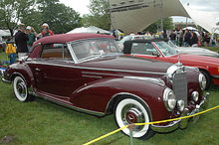
Mercedes-Benz took part in the world championship in 1954 and 1955, but despite being successful with two championship titles for Juan-Manuel Fangio, the company left the sport after just two seasons. He is considered by many to be the best F1 driver in history.
Mercedes-Benz returned as an engine supplier in the 1990s and part-owned Team McLaren for some years, to which it has supplied engines engineered by Ilmor since 1995. This partnership brought success, including drivers championships for Mika Häkkinen in 1998 and 1999, and for Lewis Hamilton in 2008, as well as a constructors championship in 1998. The collaboration with McLaren had been extended into the production of roadgoing cars such as the Mercedes-Benz SLR McLaren.
In 2007, McLaren-Mercedes was fined a record US$100 million for stea ling confidential Ferrari technical data.
In 2009, Ross Brawn's newly conceived Formula One team, Brawn GP used Mercedes engines to help win the constructor's championship, and Jenson Button to become champion in the F1 drivers' championship. At the end of the season, Mercedes-Benz sold its 40% stake in McLaren to the McLaren Group and bought 70% of the Brawn GP team jointly with an Abu Dhabi based investment consortium. Brawn GP was renamed Mercedes GP for the 2010 season and is, from this season on, a works team for Mercedes-Benz.

